STOCK MAINTENANCE SYSTEM

***PROBLEM STATEMENT***

***------------------------------***

**->**This system helps in the computerization of the stocks of a product or item.

->This makes handling the stock of a product easy.

->The number of different products,sale and purchase details and stocks will always be at our fingertips if we use Stock maintenance system.

->All the data can be maintained easily and can be retrieved any time.

***MAIN GOAL-***  This project is to reduce manual works, increase the processing speed and ensure reliability of data.

***(2.)SOFTWARE REQUIREMENT SPECIFICATION***

**INTRODUCTION-**

This software is an interface between the sales person and the customer which improves the efficiency and accuracy in the number of stocks maintained.

**PURPOSE-**

->The entire stock maintenance task is manual and if the sales and purchases demand keeps on increasing with time we need a database software and programming techniques which will make the process of maintaining huge amount of stocks easy hence meeting the demand.

**SCOPE-**

->The System provides an interface to the customer where they can fill in orders for the item needed.

->The sales person is concerned with the issue of items and can use this system.

-> Provide a communication platform between the customer and the sales person

**DEFINITIONS, ACRONYMS AND THE ABBREVIATIONS-**

-> Market Data provider: One who analyze the product and distribute the news.

-> Customer: One who takes order of product.

-> Sales person: One who maintains the stock details.

**REFERENCES-**

->IEEE Software Requirement Specification format.

**TOOLS TO BE USED-**

Eclipse IDE (Integrated Development Environment)

Rational Rose tool (for developing UML Patterns

**OVERALL DESCRIPTION-**

**PRODUCT PERSPECTIVE**

The Stock maintenance acts as an interface between the customer and the sales person. This system tries to make the interface as simple as possible and at the same time not risking the data stored in it.

**SYSTEM FUNCTIONS -**

->Secure order of information by the customer.

->To schedule the customer an appointment for manual delivery of the product.

USABILITY-

-The software should be easy to use by persons having least programming language also.

-Its interface should be simple and users should be able to use it hassle free.

SECURITY-

-The whole system should be accessed via a login portal which requires for user id and password for the administrator to view details of products information and sold products record.

PERFORMANCE-

-The SPMS should work efficiently at all times irrespective of the amount of data.

-Performance should not degrade with increasing amount of data.

**USER CHARACTERISTICS-**

1. **Customer:** The person who orders the item.

2. **Validate customer:** The items ordered by the customer are validated.

3. **Sales Detail:** Maintains the stock details after delivering the items to the customer.

**CONSTRAINTS-**

1. The customer should wait until the trade contractor and others to analyze the product.

2.The customer can give order and request of sales person to sell it.

3. Finally the sales person delivers the order.

**ASSUMPTIONS AND DEPENDENCIES-**

->The employee and Administrator must have basic knowledge of computers and English Language.

**HARDWARE REQUIREMENTS-**

->Desktop and CPU with atleast -RAM 2 Gb,HDD 512 Gb.

->Scanner and Print

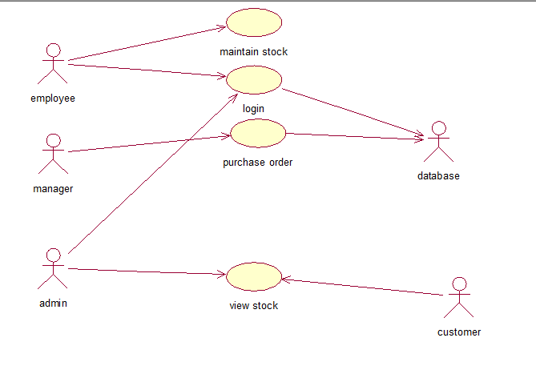Use case diagram.

